Report IDM reference No. | 2L8T2L | Version: see IDM

Final Report
on Deliverable
MAT-1.3.2-T4-D1 Status Report on the Development of the Creep Fatigue Assessment Tool

 |  | Deliverable-ID | MAT-1.3.2-T4-D1
Work Package | WPMAT | Date | 31 Oct. 2015
Project Leader | Michael Rieth
TS Title | Creep Fatigue Assessment Tool
TS Ref. No. | MAT-1.3.2-T4 | TS IDM-link | 2ME6CK
Task Owner | Michael Mahler
RU(s) | KIT

Report Review & Approval
IDM role | Name(s)
Author | Michael Mahler
Co-author(s) | Jarir Aktaa
Reviewer(s) | Michael Gorley
PMU Reviewer | Eberhard Diegele
Approver | Michael Rieth

 | Study / Assessment |  | Procurement / Commissioning of Hardware |  | Industry

 | Use of Facility | x | Other {please specify} – Interfacing and information exchange

Executive Summary
The Creep Fatigue Assessment (CFA) tool development has been continued in 2015. The major new functionality is the automated determination of the most critical path from any complex 3D geometry. This functionality was developed for ANSYS MAPDL and also integrated in ANSYS Workbench. This report shows how to use the tool in ANSYS MAPDL and Workbench, respectively. In general the identification of the most critical path is based on a selected region of interest. Therefore a surface or surfaces of interest on the inner and outer model geometry must be selected for the assessment.

Comments (shortcomings, deviations, etc.)

Table of Contents
1 Introduction and Objectives 3
2 Creep Fatigue Assessment (CFA) tool 4
3 Extension of CFA tool: Automated identification of most critical path in ANSYS MAPDL 6
3.1 Approach for automated identification of most critical path 6
3.2 Parallelisation of the CFA tool 8
3.3 User Guide for the extended approach of CFA tool in ANSYS MAPDL 8
3.3.1 CFA software package for ANSYS MAPDL 8
3.3.2 Usage of CFA tool in ANSYS MAPDL 9
4 Benchmark of extended CFA Tool on complex 3D geometry in ANSYS MAPDL 12
5 Integration of extended CFA tool to ANSYS Workbench 18
5.1 User Guide for native ANSYS Workbench model 18
5.1.1 CFA software package for ANSYS Workbench 18
5.1.2 Usage of CFA tool in native ANSYS Workbench 19
5.2 Limitations in ANSYS Workbench 23
5.3 ANSYS Workbench model in ANSYS MAPDL 23
6 Identification of requirements for expanding the tool to include the materials CuCrZr and W 23
7 Introduce CFA rule modifications identified in the CF task 24
8 Conclusions and Outlook 25
9 References 25

Abbreviations
CFA | Creep Fatigue Assessment
CF | Creep Fatigue
MAPDL | Mechanical Ansys Parametric Design Language
TBM | Test Blanket Modul
ROI | Region Of Interest
KIT | Karlsruhe Institute of Technology
dpa | displacement per atom

Symbols
$$D$$ | total damage | [-]
$$E$$ | young’s modulus | [MPa]
$$F$$ | peak stress | [MPa]
$$K$$ | local geometric concentration factor | [-]
$$K_{v}$$ | multiaxial plasticity and poisson ratio adjustment factor | [-]
$${\acute{K}}_{v}$$ | plastic poisson ratio adjustment factor | [-]
$$n$$ | number of applied repetitions | [-]
$$N_{d}$$ | number of design allowable cycles | [-]
$$P_{m}$$ | membrane stress | [MPa]
$$P_{b}$$ | bending stress | [MPa]
$$Q$$ | secondary stress | [MPa]
$${\check{R}}_{p0,2}$$ | yield stress | [MPa]
$$S^{*}$$ | stress determined by entering the stress vs. strain curve at $∆ε_{max}$ | [MPa]
$$S_{k}$$ | modified relaxation stress | [MPa]
$$S_{LB}$$ | lower bound stress | [MPa]
$$S_{m}$$ | allowable stress | [MPa]
$$S_{r}$$ | relaxation stress based on isochronous stress vs. strain curves | [MPa]
$$t$$ | duration | [s]
$$T_{d}$$ | allowable time duration | [s]
$$t_{h}$$ | one cycle hold time | [h]
$$T.F.$$ | triaxiality factor | [-]
$$W$$ | influence of triaxiality | [-]
$$X$$ | primary stress coefficient | [-]
$$Y$$ | secondary stress coefficient | [-]
$$Z$$ | ratcheting coefficient | [-]
$$∆ε_{c}$$ | creep strain range increment | [-]
$$∆ε_{max}$$ | maximum equivalent elastic strain range | [-]
$$∆ε_{mod}$$ | modified max. equivalent strain range | [-]
$$∆ε_{t}$$ | total strain range | [-]
$$∆σ_{mod}$$ | modified max. equivalent stress range | [MPa]
$σ_{1}$, $σ_{2}$, $σ_{3}$ | principal stresses in x, y, z coordinates | [MPa]
$$σ_{c}$$ | efficient creep stress | [MPa]

Introduction and Objectives
The selection of structural materials is a very important issue for in-vessel components of fusion reactors. The high dose irradiation resistance and the creep strength at elevated temperatures make EUROFER97 a strong candidate as a structural material [1].
The Creep-Fatigue Assessment (CFA) tool developed by Özkan & Aktaa [1] is able to evaluate the creep and fatigue damage as well as their interaction according to ASME Boiler Pressure Vessel Code (BPVC) Section III Division 1 Subsection NH [2]. This tool was developed for ANSYS MAPDL and uses the local stress, maximum elastic strain range and temperature from thermo-mechanical elastic analyses of a component performed with ANSYS.
For the assessment design fatigue and stress to rupture curves of EUROFER97 as well as isochronous stress vs. strain curves determined by a constitutive model considering irradiation influence are used to deal with creep-fatigue damage.
The mentioned tool can be used in ANSYS MAPDL post-processing by selection of two nodes and evaluate the allowable number of cycles, the creep and the fatigue damage on the selected path, see Section 2. The main disadvantage of the tool at the moment is that the critical region cannot be identified automatically, because the selection of the nodes must be done by the user. For this reason an extension of this tool is required to be able to identify the most critical region in the component automatically. Section 3 deals with the extension of the tool and explains how it is implemented. To show how the tool works a benchmark example is discussed in Section 4 on a complex 3D geometry.
Another important point is that the CFA tool [1] was developed for ANSYS MAPDL. Many ANSYS user prefer to use the more comfortable and user friendly ANSYS Workbench instead. The integration of the CFA tool from ANSYS MPADL to ANSYS Workbench is another interesting topic which is figured out in this report, see Section 5.
To extend the CFA tool to other materials (e.g. CuCrZr or W) it seems to be mandatory to identify the required material data. This question is answered in Section 6 and rule modifications of the creep-fatigue assessment are mentioned in Section 7.

Creep Fatigue Assessment (CFA) tool
The CFA tool is based on the creep-fatigue interaction damage model based on creep-fatigue evaluation which is available in ASME-BPVC Section III Division 1 Subsection NH T-1400 and uses the creep-fatigue failure criterion in Equation (1).
$$\sum{\left[\frac{n}{N_{d}}\right]+\sum{\left[\frac{t}{T_{d}}\right]≤D}}$$ | (1)

The first part on the left side of Equation (1) represents the fatigue damage with the number of applied repetitions $n$ and the number of design allowable cycles $N_{d}$ for the specific cycle type. The second part on the left side shows the creep damage with the duration $t$ and the allowable time duration $T_{d}$ for a specific time interval. On the right hand side of the equation the variable $D$ is the total damage of creep-fatigue interaction which is not constant. The damage $D$ for EUROFER97 is given by a creep-fatigue damage envelope as bi-linear curve [1], see Figure 1.
Figure 1 Creep-fatigue damage interaction diagram for EUROFER97 [1]
The CFA tool is able to identify the design allowable numbers of cycles, the creep and the fatigue damage fraction on a defined path.
The analysis procedure of the CFA tool by Özkan & Aktaa [1] is shown in Figure 2 in principle. The procedure starts with the definition of a path for stress linearization in ANSYS MAPDL by selecting of two nodes by hand. Followed by the collection of local data the creep-fatigue assessment according to the creep-fatigue rules in ASME BPVC is done. For this assessment design fatigue, stress to rupture and isochronous stress vs. strain curves are mandatory to calculate total strain range and relaxation stress for the determination of the one cycle fatigue and creep damage fraction. Finally the allowable numbers of cycles, fatigue and creep damage can be calculated using the creep-fatigue damage interaction diagram for the selected path.
Figure 2 Analysis procedure of Creep-Fatigue Assessment (CFA) [3]
To illustrate how complex the creep-fatigue evaluation according to ASME BPVC is, the flowchart in Figure 3 shows the required parameters for the calculation of the design allowable number of cycles. The goal in Figure 3 is to calculate the total strain range to be able to enter the design fatigue curve to determine the one cycle fatigue damage. The creep-fatigue interaction diagram helps to identify the allowable number of cycles. More details on the determination of design allowable number of cycles in the CFA tool can be found in [1].
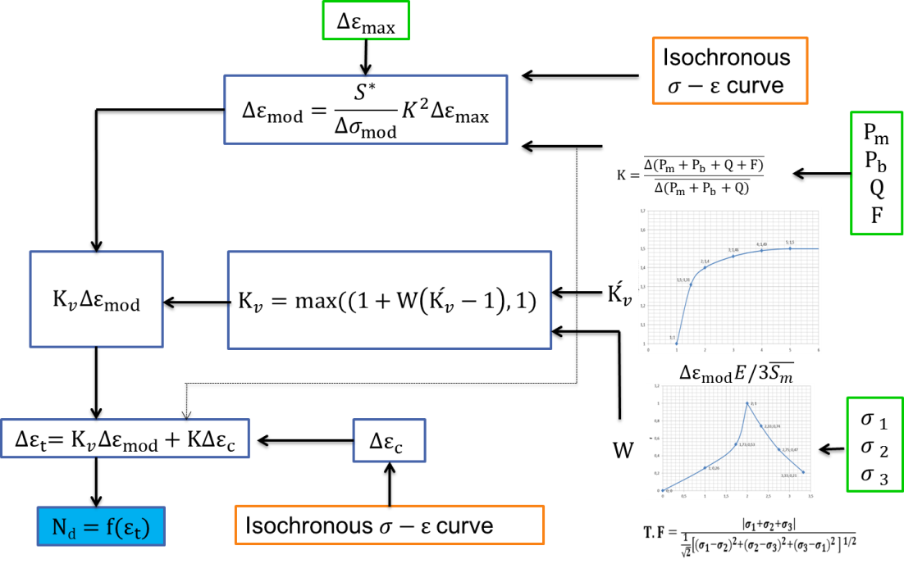
Figure 3 Flowchart for the calculation of the allowable number of cycles [1]
The second part of the creep-fatigue assessment is the calculation of the one cycle creep damage. Therefore the time to rupture which is a function of the relaxation stress during the one cycle hold time is determined using isochronous stress vs. strain curves [3] at a strain range equal to the determined total strain range before. Figure 4 shows the theoretical flow procedure for the determination of the time to rupture in detail. Based on this time to rupture the creep damage for one cycle is identified. Finally the total creep damage using the creep-fatigue interaction diagram can be calculated.
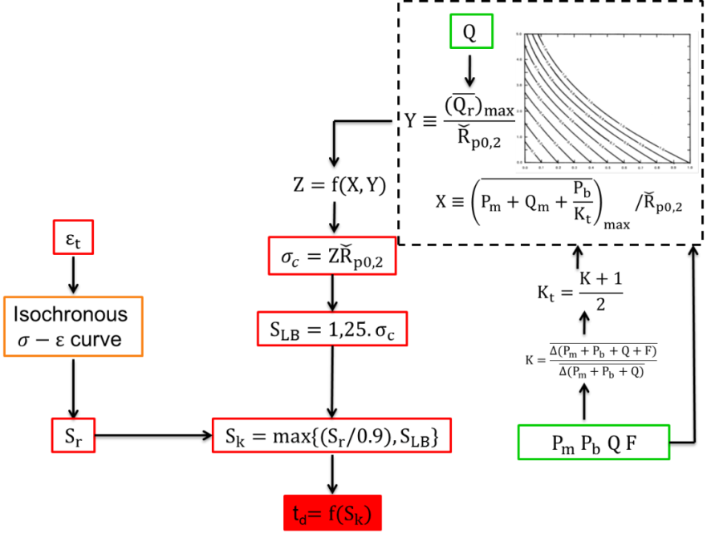
Figure 4 Flowchart for the calculation of time to rupture [1]
For more details on the theory, the program-library structure or user guide of the CFA tool see [1] and for the theoretical background on creep-fatigue rules see [2].
The CFA tool works fine for a specific path which is based on a selection of two nodes. The aim now is to extent the tool for an automated identification of the most critical path in ANSYS MAPDL.

Extension of CFA tool: Automated identification of most critical path in ANSYS MAPDL
For the extension to automated identification of the most critical path the CFA tool program-library developed by Özkan & Aktaa [1] is treated as a black box which uses two nodes for assessment.
One node is selected on the inner model geometry and the other node on the outer model geometry. A path on these two nodes is created and the linearized stresses are calculated. The automated identification of the most critical path necessitates the CFA on all paths to find the most critical one. The most critical one is treated to be the one with the lowest number of design allowable cycles to failure.

Approach for automated identification of most critical path
The idea now is to select areas on the inner and outer model geometry instead of one node on the inner and on the outer surface, respectively. Figure 5 presents the extended approach of the CFA tool which is able to identify the most critical path in any complex 3D geometry.
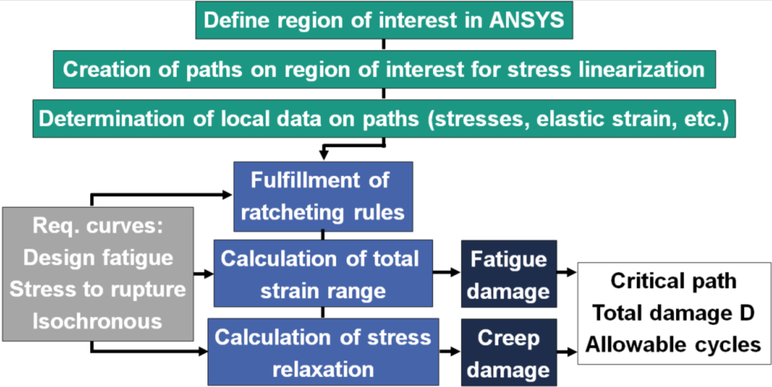
Figure 5 Extension of CFA tool to identify most critical path
The approach starts with the definition of regions of interest (ROI) in ANSYS MAPDL. In general two regions are necessary (inner region and outer region). How these regions can be defined in ANSYS MAPDL post-processing will be explained later. All nodes which are on the selected regions are extracted and result in a set of inner and a set of outer nodes. These two node sets are the basis for the next step in the approach - the creation of paths for stress linearization. It is obvious that there are a huge number of possible paths if all possible combinations between the inner and the outer set of nodes are used.
For this reason an algorithm is used which searches for the minimum distances based on the set with the lower node. Figure 6 shows an example how the algorithm works. The inner region of interest (ROI) is shown in blue and the outer ROI in purple. The shown dots are nodes on the inner or outer ROI.
Figure 6 Algorithm for minimum distance
The inner ROI has the lower number of nodes (13) and is selected to search for the minimum distances of all nodes in this ROI. For example the minimum distance (shown in red) for node “N_S_I10” on the inner ROI is obtained with node “N_S_O9” on the outer ROI. These two nodes are used to build one of the 13 paths (because of 13 nodes on the inner ROI).
For all these node pairs paths are created. Using only the minimum distances between inner and outer region is an acceptable assumption, because other possible distance combinations are in practice in rare cases (e.g. by using a very coarse mesh) and however the tool provides realistic results for the chosen distances.
Now the approach determines all local data (stresses, elastic strain range and temperature) on the paths sequentially. On each path the CFA runs as developed by Özkan & Aktaa [1] and identifies
- design allowable number of cycles,
- creep damage,
- fatigue damage.
For all paths these three values are stored and later the one with the lowest design allowable number of cycles is figured out and treated as the most critical path on the selected ROI.
This works fine for models with a low number of paths to be assessed. For larger models and a huge number of paths a parallelization for computing the CFA result on multiple cores mandatory to reduce simulation time.

Parallelisation of the CFA tool
For a faster assessment on models with a lot of paths to be analysed the CFA tool, which is in the current implementation not able to be run in parallel execution, must be re-written in FORTRAN to add this functionality.
Therefore the internal environment variables of CFA tool must been changed from a global variable list to local ones. This functionality needs to be added in 2016.

User Guide for the extended approach of CFA tool in ANSYS MAPDL
The CFA tool is an implementation of the elastic creep-fatigue damage evaluation for EUROFER97 components as a post-processor in the finite element code ANSYS MADPL.
The tool has been initially developed by Özkan & Aktaa [1] and was extended by the authors of this report. CFA tool is a property of their organisation, the Karlsruhe Institute of Technology (KIT). It will be provided for users as encrypted files, which can be copied or used only on the base of and according to a licence agreement with the developer organisation, the Karlsruhe Institute of Technology.
In the following the use of the CFA tool will be described on a 64 bit Windows system with an ANSYS MAPDL 15.0 installation.

CFA software package for ANSYS MAPDL
The CFA encrypted files for MAPDL will be delivered in a file called:
CFA_MPADL.zip
This file contains the 8 files:
!Toolbar
CFA.exe
mac-1.mac
mac-inner-geometry.mac
mac-inner-geometry-apply.mac
mac-outer-geometry.mac
mac-outer-geometry-apply.mac
mac-2.mac
The files within this *.zip file should be extracted in the current used working directory of ANSYS MAPDL, for instance:
C:\Documents\ANSYS-Working-directory\Test-Project.
In this working directory the result files of the structural and thermal for the temperature distribution, the primary and the primary + secondary stress analysis as well as the model file must be available with the following file names:
geometry data file: model.db
temperature result file for temperature distribution: thermal.rth
structural result file for primary loads: primary.rst
structural result file for primary + secondary load: primary+secondary.rst
Keep care to rename the files accordingly, because it is mandatory to be able to use the CFA tool. To avoid mix up of simulation files it is recommended to run each CFA in a separate folder.

Usage of CFA tool in ANSYS MAPDL
In the past the old version requires two steps during post-processing of the two nodes which are selected by hand. The new version for automated path identification requires six steps which will be explained in detail within this section.
After copying the extracted files in the work directory check once more the correct file names for the ANSYS model and result files.
The next step in ANSYS MAPDL is to add the toolbar for CFA. This can be done by clicking on “Parameters” and select “Restore Parameters”, see Figure 7. A new window opens and with the button “Browse” the file “!Toolbar” from the CFA_MAPDL.zip file must be selected to add the toolbar.
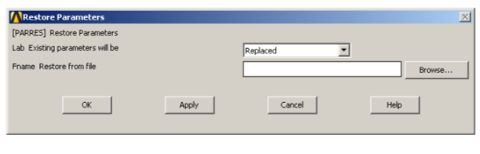
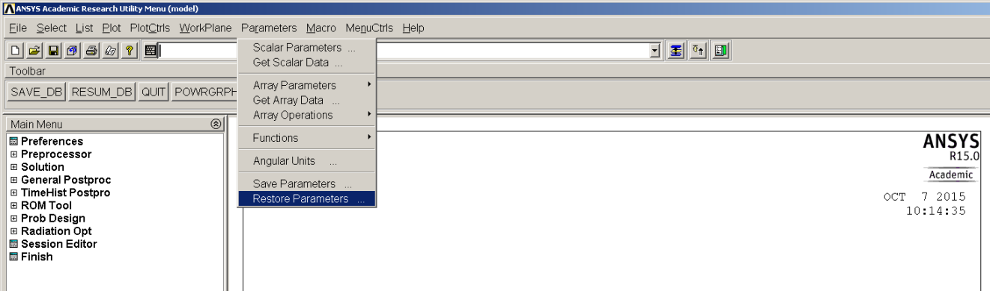
Figure 7 CFA tool add toolbar
As a result six boxes (highlighted in red in Figure 8) appear which correspond to the six required steps during post-processing of CFA.
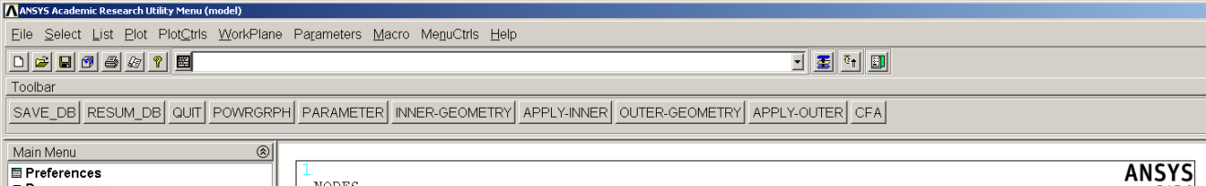
box:
6
5
4
3
2
1
Figure 8 CFA toolbar in ANSYS MAPDL
Now it is required to click the six boxes step by step starting with box. Using another sequence will lead to errors and ANSYS MAPDL must be restarted. The steps will be explained in the following in more detail step by step:
Step 1: “PARAMETER”  Clicking on the box “PARAMETER” opens a new window where the input parameter for the CFA can be defined, see Figure 9. The parameters are:  - Hold time time $t_{d}$ in hours  - Irradiation rate in dpa per year  - Dimension of finite element model  2D model geometry -1  3D model geometry 0  - Kind of ROI selection  Point 1  Line 2  Area 3 | 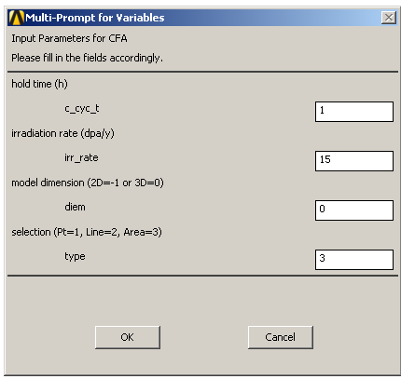  Figure 9 Input parameter for CFA
Step 2: “INNER-GEOMETRY”  After definition of the input parameters. The second box “INNER-GEOMETRY” opens two new windows. One shows the message:  “Please define the inner areas for stress linearization”  This window can be closed. The other window is for the selection of the ROI. In that case the selection of areas. Now all inner areas of interest must be selected, see purple surfaces in Figure 10. Then click “OK.” | 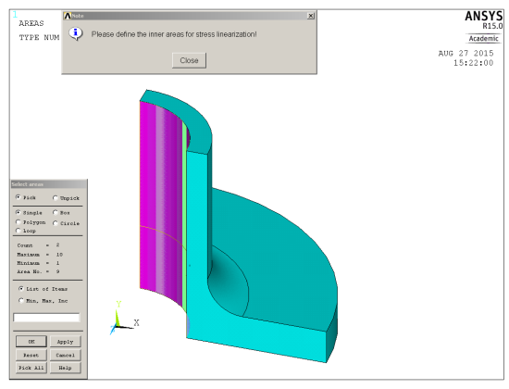  Figure 10 Definition of inner ROI
Step 3: “APPLY-INNER”
To confirm the selected inner areas the box “APPLY-INNER” must be clicked now.
Step 4: “OUTER-GEOMETRY”  The outer ROI (see Figure 11) can be defined by clicking the box “OUTER-GEOMETRY” and select the areas of interest as described in Step 2. | 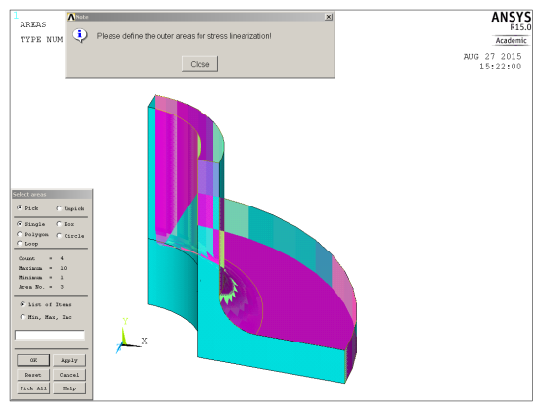  Figure 11 Definition of outer ROI
Step 5: “APPLY-OUTER”
To confirm the selected outer areas in the step before the box “APPLY-OUTER” must be clicked now.
Step 6: “CFA”  To start the CFA press the box “CFA”. The evaluation starts with the extraction of the attached nodes within the inner and outer ROI, see Figure 12. Followed by the identification of the minimum distances and the creation of the required path.  In addition all elements on the identified paths are selected and reduced result files for thermal, primary and primary + secondary analysis are created. This is necessary to increase the computation speed, because it is faster to deal with result files of smaller size.  Finally the CFA identifies the most critical path according to ASME BPVC creep-fatigue rules and shows the result on screen in ANSYS MAPDL (see later Figure 17 and Figure 18). | 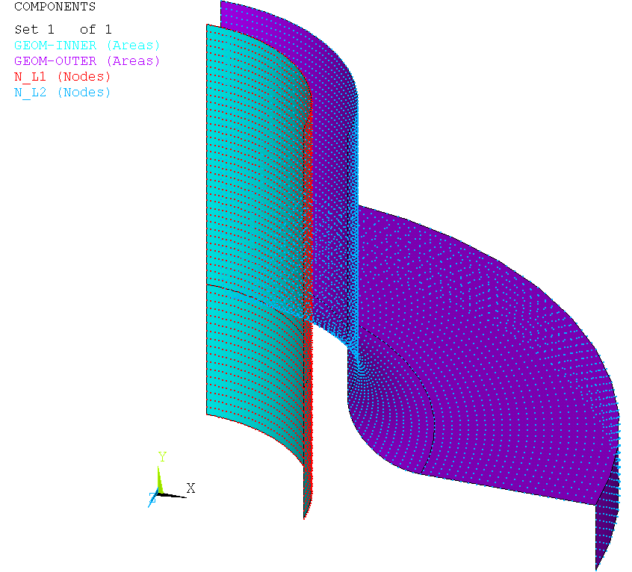  Figure 12 Selected inner and outer ROI

During the CFA additional twelve text files are created. Four of this twelve text files with the name “INPUT_....txt”contain the input data, which is extracted from ANSYS MAPDL during post processing of the thermal, primary and primary+secondary result files. The content of these files will not be explained, but these four files can be used to run the CFA.exe independent from ANSYS MAPDL.
The remaining eight text files with the name “OUTPUT_....txt” contain the result information of CFA and will be explained in detail in the following:
- OUTPUT_Nmax.txt
This file contains the maximum design allowable cycles $N_{d}$ on the identified critical path.
- OUTPUT_dc.txt
This file contains the creep damage on the identified critical path.
- OUTPUT_df.txt
This file contains the fatigue damage on the identified critical path.
- OUTPUT_CFA_summary.txt
This file contains a summary of different important values from the CFA on the identified critical path: # fatigue damage “df”
# creep damage “dc”
# max. cycles “max. allowable number of cycles”
# primary + secondary stresses “P+Q”
# prim. + sec. stress coefficient “X+Y”
# max. total strain range “max_str_tot”
# max. temperature “max_Temp”
# min. temperature “min_Temp”
# average temperature “avg_Temp”
# max. 3S_{m} value “3Sm_max”
# min. 3S_{m} value “3Sm_min”
- OUTPUT_Critical_path_node1.txt
This file contains the node number of the first node of the identified critical path.
- OUTPUT_Critical_path_node2.txt
This file contains the node number of the second node of the identified critical path.
- OUTPUT_elastic-total-strain-path.txt
This file contains three columns with values on the identified critical path:
1st column: relative path position
2nd column: von Mises elastic strain $∆ε_{max}$
3rd column: total strain range$∆ε_{t}$
- OUTPUT_stress-relaxation-hold.txt
This file contains three columns with values corresponding to the identified critical path.
1st column: one cycle hold time in seconds
2nd column: relaxation stress $S_{r}$
3rd column: lower bound stress$S_{LB}$

Benchmark of extended CFA Tool on complex 3D geometry in ANSYS MAPDL
To show how the CFA tool is able to identify the most critical path in a selected region of interest a complex 3D benchmark example is used. Therefore a muff of EUROFER97 material with an inner pressure of 20 bar and temperature of 500 °C on the inner and 450 °C on the outer surface of the muff using symmetry boundary conditions have been performed with ANSYS MAPDL. The finite element mesh is shown in Figure 13.
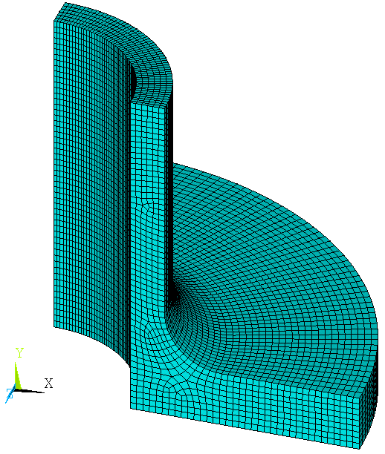
Figure 13 Finite element mesh of complex 3D geometry
Figure 14 a) shows the result of the steady state thermal analysis with the temperature distribution between the inner and the outer surface of the muff. This temperature distribution is used for the first elastic structural analysis considering the primary loads (inner pressure). The distribution of the equivalent total elastic thermal and mechanical strain is shown in Figure 14 b) with its maximum value of 4.6·10⁻⁵ on the inner surface of the muff. The second elastic structural simulation considering the primary + secondary loads (inner pressure and thermal expansion) yields a maximum equivalent total elastic thermal and mechanical strain of 5.3·10⁻⁴, see Figure 14 c). [4]
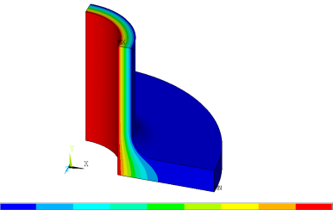  3.6·10⁻⁶  500  450  a) thermal loads | 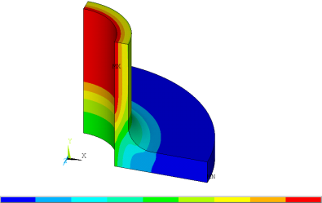  1.6·10⁻⁵  4.6·10⁻⁵  b) primary loads | 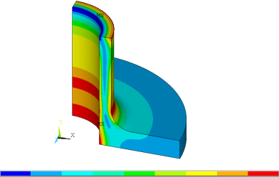  5.3·10⁻⁴  c) primary+secondary loads
Figure 14 Thermo-mechanical analysis on complex 3D geometry
Based on these three elastic analyses the CFA tool is able to identify the most critical path by post-processing.
After adding the CFA Toolbar to ANSYS MAPDL the additional six boxes, which are
- “PARAMETER”,
- “INNER-GEOMETRY”,
- “APPLY INNER”,
- “OUTER GEOMETRY”,
- “APPLY OUTER” and
- “CFA”
have to be clicked step by step starting with the box “PARAMETER”, see Figure 15. This box opens a new window where the parameters for CFA must be defined. In that case a hold time of 1 hour and a irradiation dose of 15 dpa/year is used. In addition a flag for model dimension must be set. If the finite element model is 3D the number zero is required. One more parameter is required for the kind of selected region which is used later. This can be point (1), line (2) or area (3). When point is used then the CFA runs only for one path based on the selected two points. Now area is used to be able to select areas of interest.
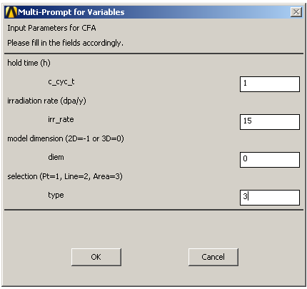
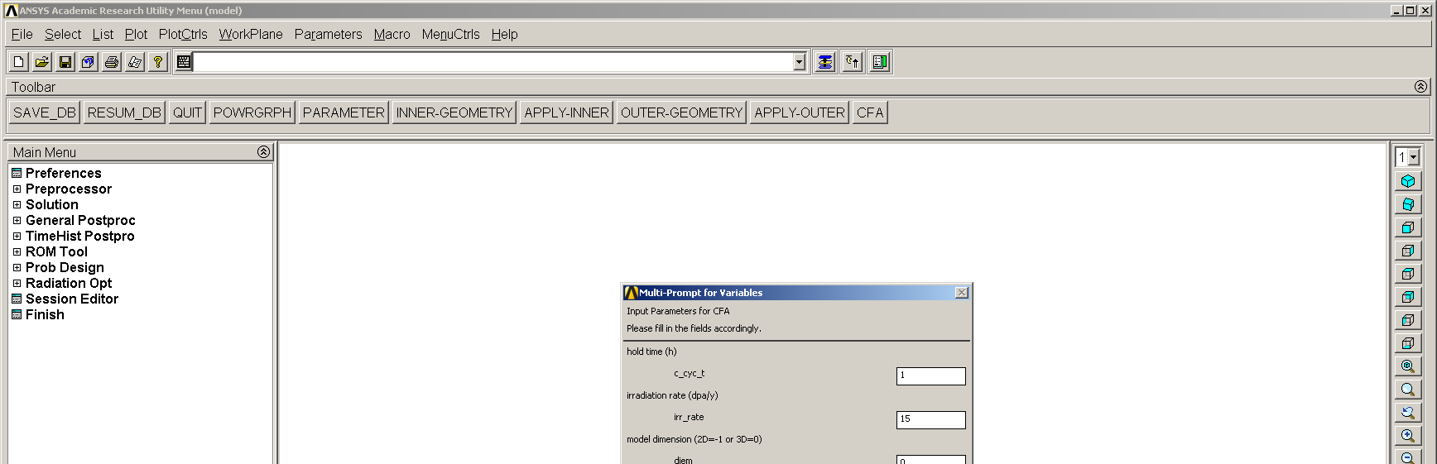
Figure 15 Definition of CFA input parameters for 1 hour hold time and irradiation rate of 15 dpa/year
To identify the most critical path an inner and outer region must be defined. Clicking on the box “INNER-GEOMETRY” opens a window with the message “Please define the inner areas for stress linearization”. Figure 16 shows the selected inner areas in purple. With the box “APPLY-INNER” the selection is confirmed. The same procedure is required for the outer geometry using the boxes “OUTER-GEOMETRY” and “APPLY-OUTER”.
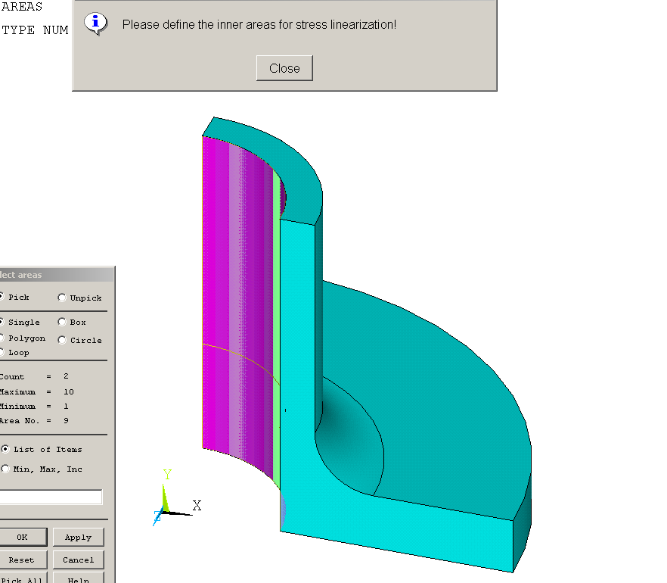
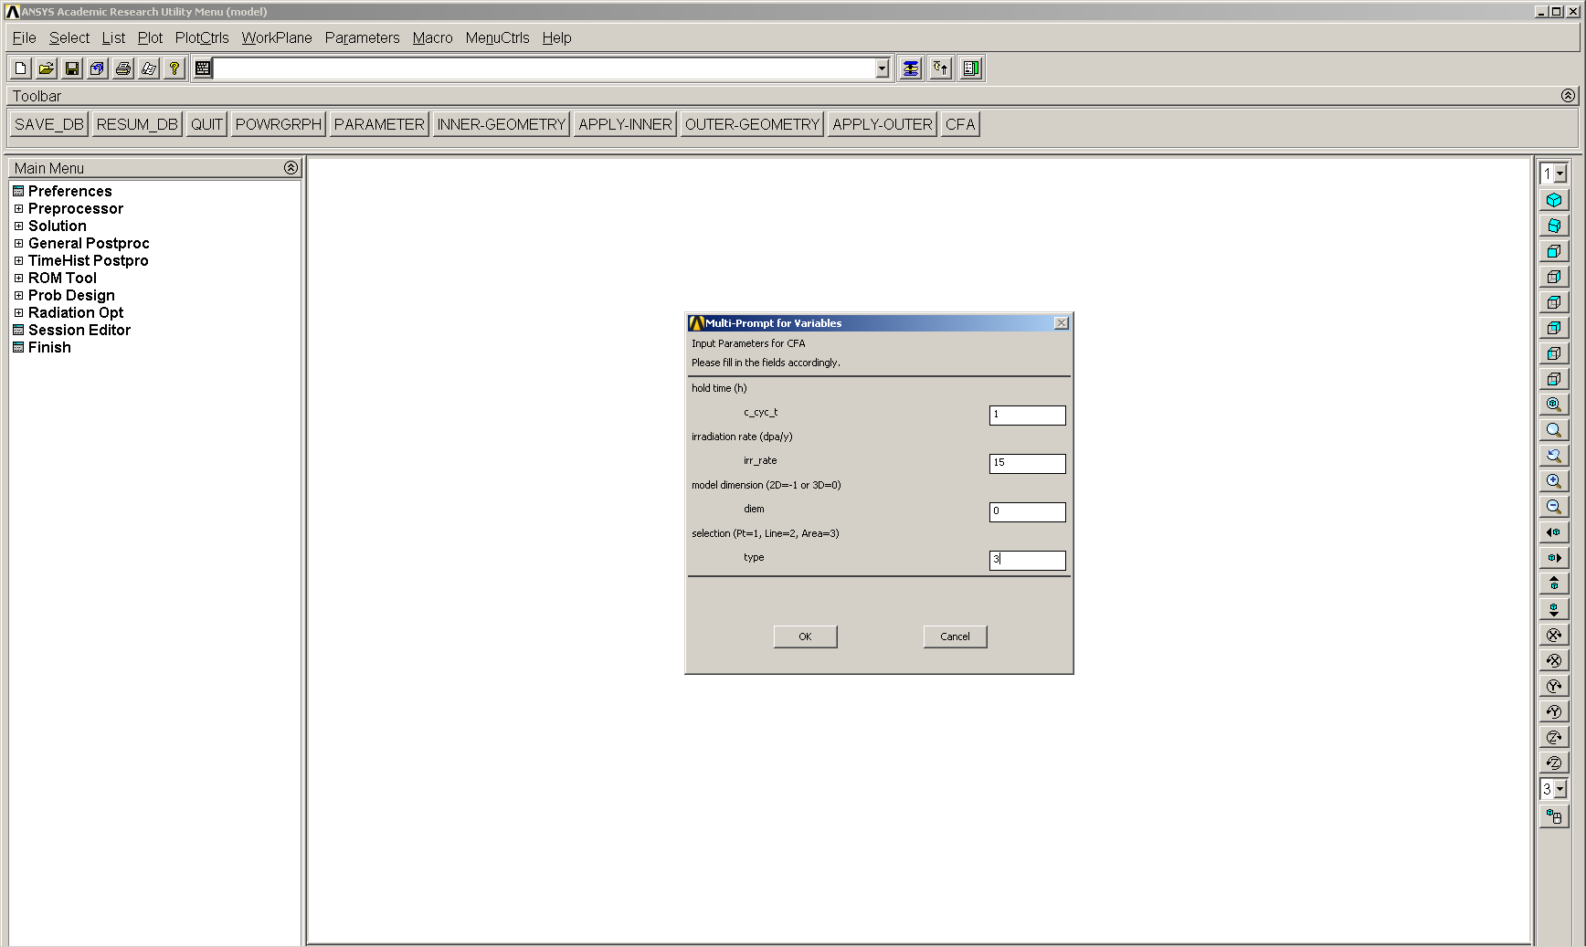
Figure 16 Selection of the inner area of interest
The Creep-Fatigue Assessment can be started by clicking the box “CFA”. During CFA the selected inner and outer area is visible on screen, see Figure 17. In this example the green surface in Figure 17 is picked for the inner (“GEOM-INNER”) and the purple surface for the outer (“GEOM-OUTER”) region, respectively.
 | 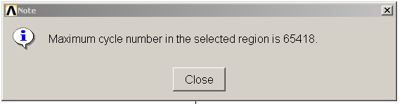
Figure 17 Selection of inner and outer region of interest | Figure 18 CFA results for 15 dpa/year
Based on these two surfaces the nodes adjacent to them are selected to result in a set of inner (“N_L1”) and outer nodes (“N_L2”). Next an algorithm searches for the minimum distance between inner and outer region and selects all elements which are on that minimum distance paths. The CFA tool linearizes the stresses along all that paths and calculates the allowable number of cycles, the creep and the fatigue damage. After that calculation the minimum allowable number of cycles is identified to figure out the most critical path and its position.
Figure 18 shows the result in ANSYS MAPDL of the CFA for an irradiation dose of 15 dpa per year. ANSYS MAPDL shows on screen the position of the critical path within the finite element mesh highlighted in red (Figure 18 left) and also the creep and fatigue damage visualized in the creep-fatigue damage interaction diagram (Figure 18 right). A prompt on screen shows in addition the maximum allowable number of cycles for this critical path which is equal to 65418 cycles for one hour hold time. The results of other hold times at same irradiation dose are listed in Table 1. [4]
Table 1CFA results for different hold times and irradiation rate of 15 dpa per year
Hold time  [hour] | Allowable cycles  [-] | Fatigue damage  [-] | Creep damage  [-]
0 | >100000 | 1 | 0
1 | 65418 | 0.065 | 0.411
100 | 2370 | 0.002 | 0.979
1000 | 323 | 0.000 | 0.997
It is clearly visible that an increase in hold time reduces the fatigue and increases the creep damage. As a result the allowable numbers of cycles decrease with increasing hold time on the most critical path.
The results written in the text files with the names “OUTPUT_....txt”during CFA for a hold time of one hour and an irradiation dose of 15 dpa per year are discussed in this paragraph. All values correspond to the identified critical path:
- OUTPUT_Nmax.txt
0.65418680E+05 | max. cycle number

- OUTPUT_dc.txt
0.41123189E+00 | creep damage

- OUTPUT_df.txt
0.65418680E-01 | fatigue damage
- OUTPUT_CFA_summary.txt
df | = 0.6542E-01 | [-] | fatigue damage
dc | = 0.4112E+00 | [-] | creep damage
max. allow. number of cycles | = 0.6542E+05 | [-] | max. cycle number
P + Q | = 0.1552E+03 | [MPa] | primary + secondary stress
X + Y | = 0.3772E+00 | [-] | prim. + sec. stress coefficient
max_str_tot | = 0.1074E-02 | [-] | maximum total strain
max_Temp | = 0.5000E+03 | [°C] | maximum temperature
min_Temp | = 0.4500E+03 | [°C] | minimum temperature
avg_Temp | = 0.4765E+03 | [°C] | average temperature
3Sm_max | = 0.3945E+03 | [MPa] | maximum 3Sm
3Sm_min | = 0.3945E+03 | [MPa] | minimum 3Sm

- OUTPUT_Critical_path_node1.txt
0.74540000E+04 | node number of first node

- OUTPUT_Critical_path_node2.txt
0.66200000E+04 | node number of second node

- OUTPUT_elastic-total-strain-path.txt
relative path length [%] | elastic strain [-] | total strain [-]
0.4000E+01 | 0.5282E-03 | 0.1074E-02
0.9000E+01 | 0.5282E-03 | 0.1073E-02
0.1400E+02 | 0.5242E-03 | 0.1068E-02
0.1900E+02 | 0.4131E-03 | 0.9557E-03
0.2300E+02 | 0.4045E-03 | 0.9461E-03
0.2800E+02 | 0.3132E-03 | 0.8539E-03
0.3300E+02 | 0.2990E-03 | 0.8388E-03
0.3800E+02 | 0.2301E-03 | 0.7689E-03
0.4200E+02 | 0.2096E-03 | 0.7475E-03
0.4700E+02 | 0.2096E-03 | 0.7466E-03
0.5200E+02 | 0.1515E-03 | 0.6876E-03
0.5700E+02 | 0.1515E-03 | 0.6866E-03
0.6100E+02 | 0.1416E-03 | 0.6757E-03
0.6600E+02 | 0.1357E-03 | 0.6688E-03
0.7100E+02 | 0.1566E-03 | 0.6887E-03
0.7600E+02 | 0.1566E-03 | 0.6876E-03
0.8000E+02 | 0.1704E-03 | 0.7003E-03
0.8500E+02 | 0.1704E-03 | 0.6992E-03
0.9000E+02 | 0.1946E-03 | 0.7222E-03
0.9500E+02 | 0.2354E-03 | 0.7618E-03
0.1000E+03 | 0.2071E-03 | 0.7322E-03

Based on the data in the *.txt file the von Mises elastic strain and the total strain range can be plotted against the relative path length of the identified critical path, see Figure 19. In general the total strain range (red) along the path is on a higher level than the von Mises elastic strain (black) and the maximum occurs in this case at the beginning of the path by 0 %:

Figure 19 Von Mises elastic strain and total strain range along the critical path
- OUTPUT_stress-relaxation-hold.txt
hold time [sec] | relaxation stress [MPa] | low bound stress [MPa]
0.0000E+00 | 0.1910E+03 | 0.7286E+02
0.1800E+03 | 0.1898E+03 | 0.7286E+02
0.3600E+03 | 0.1890E+03 | 0.7286E+02
0.5400E+03 | 0.1884E+03 | 0.7286E+02
0.7200E+03 | 0.1880E+03 | 0.7286E+02
0.9000E+03 | 0.1876E+03 | 0.7286E+02
0.1080E+04 | 0.1872E+03 | 0.7286E+02
0.1260E+04 | 0.1870E+03 | 0.7286E+02
0.1440E+04 | 0.1867E+03 | 0.7286E+02
0.1620E+04 | 0.1865E+03 | 0.7286E+02
0.1800E+04 | 0.1863E+03 | 0.7286E+02
0.1980E+04 | 0.1861E+03 | 0.7286E+02
0.2160E+04 | 0.1859E+03 | 0.7286E+02
0.2340E+04 | 0.1858E+03 | 0.7286E+02
0.2520E+04 | 0.1857E+03 | 0.7286E+02
0.2700E+04 | 0.1855E+03 | 0.7286E+02
0.2880E+04 | 0.1854E+03 | 0.7286E+02
0.3060E+04 | 0.1853E+03 | 0.7286E+02
0.3240E+04 | 0.1852E+03 | 0.7286E+02
0.3420E+04 | 0.1851E+03 | 0.7286E+02
0.3600E+04 | 0.1850E+03 | 0.7286E+02

Based on the data in the *.txt file relaxation stress and the lower bound stress can be plotted against the one cycle hold time of the identified critical path, see Figure 20. The red line shows the lower bound stress which can be interpreted as a lower limit for stress relaxation. The black curve shows how the stress relaxes during the one hour hold time (3600 sec). In that case the amount of relaxation is very low.

Figure 20 Relaxation stresses and low bound stress during one cycle hold time

Integration of extended CFA tool to ANSYS Workbench
This section deals with the integration of the extended CFA tool of ANSYS MAPDL, which works for complex 3D geometry, into ANSYS Workbench. Section 5.1 explains how the CFA tool can be used for post-processing in a native ANSYS Workbench model. Limitations in use of ANSYS Workbench for CFA are figured out in Section 5.2. In addition the use of ANSYS Workbench result files in ANSYS MAPDL is shown in Section 5.3 due to the problems occurred in ANSYS Workbench.

User Guide for native ANSYS Workbench model
The complex structure and linking possibilities between different analyses limits the integration of the CFA tool to be used in ANSYS Workbench. Nevertheless it is possible, but requires some more steps than in ANSYS MAPDL which have to be defined by the user itself.

CFA software package for ANSYS Workbench
The CFA encrypted files for ANSYS Workbench will be delivered in a file called:
CFA_WB.zip
This file contains three folders called
- “00-MACROS”,
- “00-WB-results” and
- “01-CFA-input”.
The folder “00-MACROS” contains the required six script files for ANSYS Workbench. Three of them are necessary to extract the result files of the preliminary analyses (see Figure 21 later).
These files are called:
- “WB-THERMAL.mac”
- “WB-PRIMARY.mac”
- “WB-PRIMARY+SECONDARY.mac”
The remaining three script files are used to extract the information and to run the creep-fatigue assessment.
These files are called:
- “CFA-INPUT”
- “CFA-SELECT-NODES”
- “CFA-RUN”
The second folder “00-WB-results” is empty and later used to store the required result files. The last folder “01-CFA-input” contains the “CFA.exe” file which is executed during creep-fatigue assessment. After CFA the result files are stored within this folder.
The folders within this *.zip file must be extracted in the current working directory of ANSYS Workbench, for instance:
C:\Documents\ANSYS-Working-directory\Test-Project

Usage of CFA tool in native ANSYS Workbench
The basis for the creep-fatigue assessment are the already solved analyses for the
- temperature distribution,  - primary loads and  - primary + secondary loads  in ANSYS Workbench. | 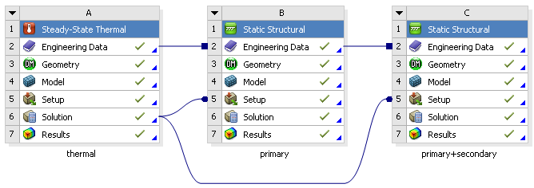  Figure 21 Required analysis for CFA
An example how these three preliminary analyses could be performed in ANSYS Workbench is shown in Figure 21. The left box shows the steady-state thermal analysis for the temperature distribution and the box in the middle and on the right show the static structural elastic analyses for primary and primary+secondary loads respectively. The primary+secondary analysis includes the influence of thermal expansion compared to the primary one. Nevertheless both analyses are linked to the thermal analysis to receiver temperature distribution information.
The next seven steps explain how the CFA tool can be used for ANSYS Workbench step by step starting with the extraction of result files of the preliminary analyses.
Step 1: Extract result files
Due to the complex file structure of ANSYS Workbench the result files of these three analyses must be extracted accordingly. This can be done by using the three different script files named

- WB-THERMAL.mac,
- WB-PRIMARY.mac and
- WB-PRIMARY+SECONDARY.mac.

The use of these script files will now be explained for “WB-THERMAL.mac”:
- By double clicking on the “Results” of the analysis e.g. steady-state thermal (see red box in Figure 21) a new window opens. In this new window an APDL command must be added (see red box in Figure 22).  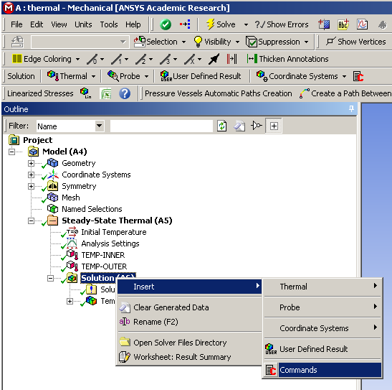  Figure 22 Add MAPDL command | - By right cklicking on this added command the script file called “WB-THERMAL.mac” can be imported (see red box in Figure Figure 23). The script can be executed by clicking on “Solve”.  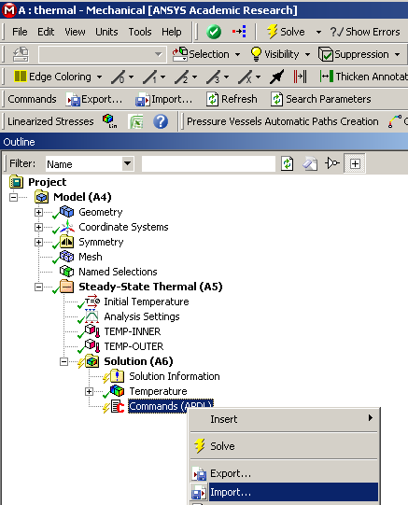  Figure 23 Import of macro file
Following this procedure for all three named script files the result files are extracted accordingly in the subfolder “00-WB-results” of the folder “CFA” in the current work directory. As a result the files

- “thermal.rth”,
- “model.db”,
- “primary.rst” and
- “primary+secondary.rst”

are visible in this subfolder.

Note:
Step 1 can be skipped if the four listed files above are moved to this subfolder by hand and the three script files called

- “WB-THERMAL.mac”,
- “WB-PRIMARY.mac” and
- “WB-PRIMARY+SECONDARY.mac”

are not required in this case!
Step 2: Add a mechanical model  The second step is to add an additional mechanical model to the project. This model should be linked with the model of the steady-state thermal analysis, see Figure 24. | 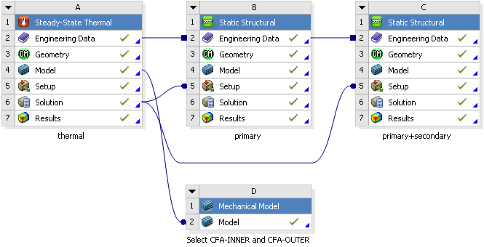  Figure 24 Add mechanical model
Step 3: Add named selection
By double clicking on this model a new window opens. Two “Named Selections” must be added to the model as shown in Figure 25. Then this two “Named Selections” are visible in the model tree with an unspecified name and one of them must be renamed to “CFA-INNER” and the other to “CFA-OUTER”, see red box in Figure 26. For both selections the regions of interest have to be defined for the inner and the outer geometry. The two red surfaces in Figure 26 show the selections.
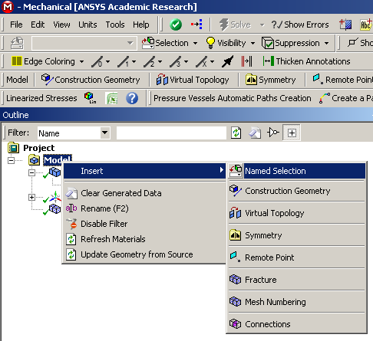  Figure 25 Add named selection | 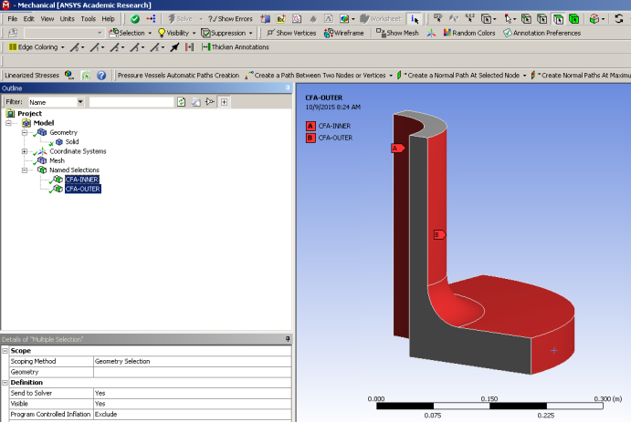  Figure 26 CFA-INNER and CFA-OUTER
Step 4: Add 1st mechanical APDL
The next step is to add a 1st mechanical APDL model to the project scheme and link it with the mechanical model defined before. Then right click on “Analysis” of the mechanical APDL model and select “Add Input File” to browse for the required script files, see Figure 27.

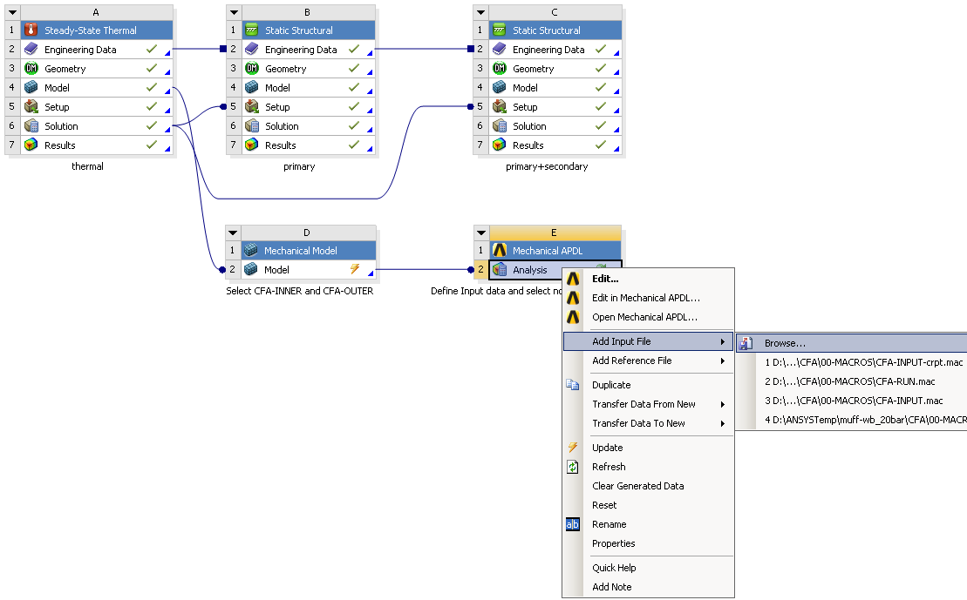  Figure 27 Add 1st mechanical APDL | 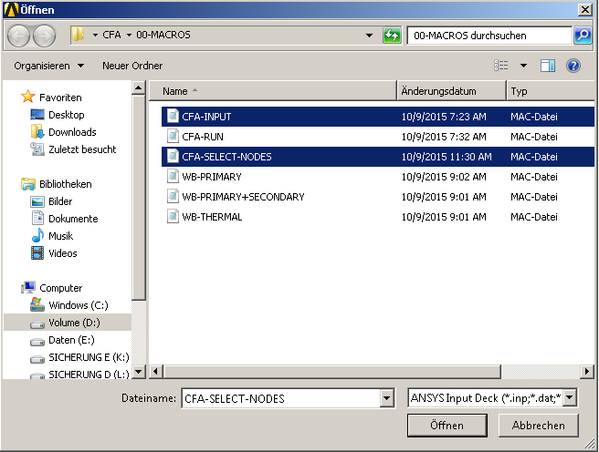  Figure 28 Add input files
Two script files must be added. The first one is called “CFA-INPUT.mac” and the second one “CFA-SELECT-NODES.mac”, see Figure 28.  To be able to change the input parameters for the CFA tool a right click on “Analysis” in the mechanical APDL box is required.  Now select “Edit” to open a new window. The input parameters for CFA are visible when the Process “CFA-INPUT.mac” is selected; see red boxes in Figure 29. Three check marks must be set as Input values. | 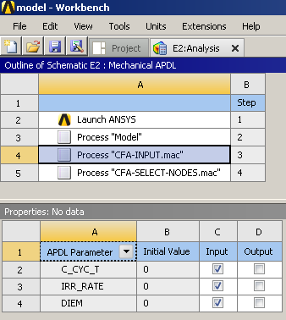  Figure 29 Select CFA parameters for input
Step 5: Define CFA input parameter
Double clicking on “Parameter Set” which is now available and linked with the “Parameters” in the mechanical APDL box (Figure 30) opens a table (Figure 31) which allows the definition of the three parameters of the CFA tool:

- “C_CYC_T”: Hold time time $t_{d}$ in hours
- “IRR_RATE”: Irradiation rate in dpa per year
- “DIEM”: Dimension of finite element model: 2D model geometry -1
3D model geometry 0
After the definition of CFA input parameter the 1st mechanical APDL box can be updated by right clicking on “Analysis” “Update”. When a green check marker appears everything works fine and two text files are generated in the Subfolder “01-CFA-input” named

- “INPUT-user.txt” and
- “INPUT-nodenumber”

which will be used in step 6 for CFA.

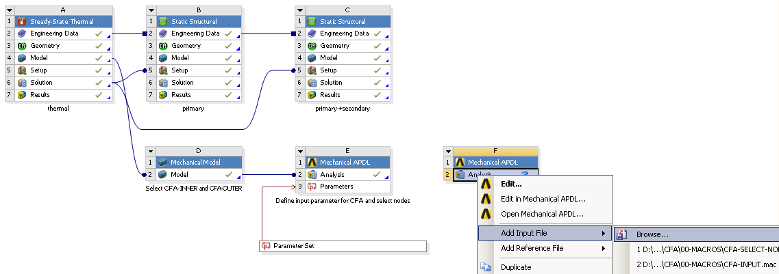  Figure 30 Project scheme status | 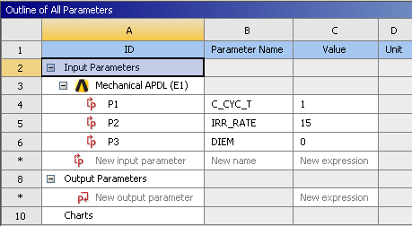  Figure 31 Define CFA input parameters
Step 6: Add 2nd mechanical APDL
One more mechanical APDL box is required. No linking to another box is necessary. The last available macro called “CFA-RUN.mac” must be added to the “Analysis” in the 2nd mechanical APDL box, see Figure 32.
Figure 32 Add 2nd mechanical APDL
Step 7: Run CFA
To finally start the Creep-Fatigue Assessment (CFA) tool the ”Analysis” in the 2nd mechanical APDL box must be updated as shown in Figure 33. During the assessment ANSYS Workbench is busy and after some time a green check mark appears and the result files are available in the Subfolder “01-CFA-input”.
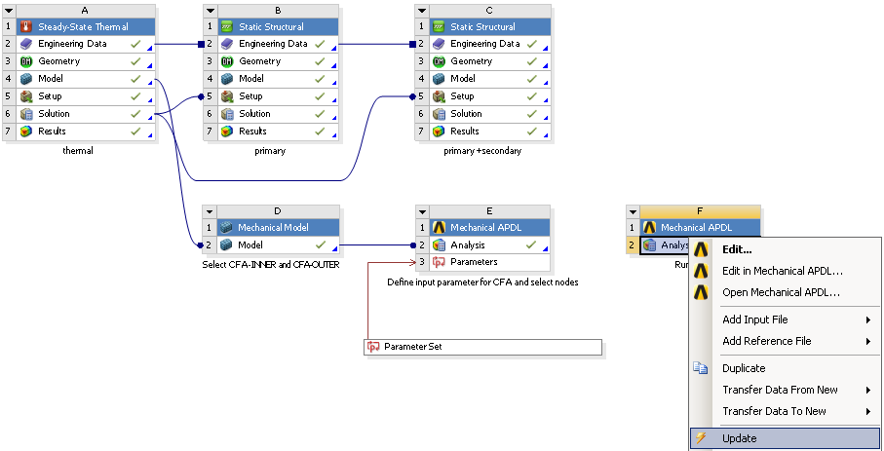
Figure 33 Run CFA in ANSYS Workbench

For ANSYS MAPDL the visualization of the results works fine, but for ANSYS Workbench a visualization of the results is not implemented. A solution for this disadvantage in ANSYS Workbench could be carried out in 2016. But nevertheless the CFA works in ANSYS Workbench, but the results are available in the “OUTPUT_...” text files only which can be found in the subfolder “01-CFA-input” within the folder “CFA” of the work directory. The content of the text files was already discussed in Chapter 4.

Limitations in ANSYS Workbench
The usage of CFA tool in native ANSYS Workbench model as shown in Section 5.1 is more complicated compared to ANSYS MAPDL. The main disadvantages are listed below:
- A lot of additional steps have to be added to the project scheme by the user itself.
- Definition of CFA input parameters is not user-friendly.
- A visualization of the results like in ANSYS MAPDL is not possible.
- Results are only available in the corresponding text files.
Due to these disadvantages the authors recommend to use ANSYS MAPDL instead of ANSYS Workbench.

ANSYS Workbench model in ANSYS MAPDL
Run a CFA based on preliminary analyses for thermal, primary and primary+secondary loads obtained with ANSYS Workbench in ANSYS MAPDL can be done very easy. From the preliminary analyses in ANSYS Workbench the corresponding data for the
geometry data file: “model.db”
temperature result file for temperature distribution: “thermal.rth”
structural result file for primary stresses: “primary.rst”
structural result file for primary + secondary stresses: “primay+secondary.rst”
must be moved to an ANSYS MAPDL work directory. It is mandatory that the files are named as mentioned above. No other file names are accepted.
If these requirements are met, the CFA based on ANSYS Workbench result files can be assessed using ANSYS MAPDL as shown in Chapter 3.

Identification of requirements for expanding the tool to include the materials CuCrZr and W
Until now the CFA tool is only working for components made of EUROFER97 in a temperature range between room temperature and 650°C. For an expansion of the tool to include the materials CuCrZr or W a lot of experimental data is required at different temperatures. To deal with fatigue damage the design fatigues curves and for creep damage the stress to rupture curves are mandatory. To fulfil the creep-fatigue rules in ASME BPVC the isochronous stress vs. strain curves are necessary in addition. If the influence of irradiation needs to be considered, then e.g. a constitutive model is required to calculate the required stresses and strains for the creep-fatigue assessment. Furthermore the creep-fatigue damage interaction diagram as shown in ASME BPVC has to be defined.

To summarize the requirements the items listed below are mandatory for the temperature range of interest and can be added to the CFA Fortran code in terms of equations:
- Design fatigue curves
- Creep stress to rupture curves
- Isochronous stress vs. strain curves (including irradiation)
- Yield stress
- Creep-fatigue damage interaction diagram
To get an idea how these curves look like some examples for EUROFER97 material are shown in Figure 34.
- Design fatigue curves [5] | - Creep stress to rupture curves [6]
- Isochronous stress vs. strain curves [3], [7] [8], [4] | - Interaction diagram [2]
Figure 34 Required CFA material data of EUROFER97 [4]

Introduce CFA rule modifications identified in the CF task
Before including CFA rule modifications it is necessary that proposed modifications of the creep-fatigue accumulations rules [9] have to be verified on EUROFER97. The modifications require material data not yet available for EUROFER97. The creep-fatigue tests for missing data as mentioned in the CF task [9] are:
- Strain controlled LCF tests with hold times ( > 30 min)
- Sequence tests
- Thermo-mechanical cyclic tests with/-out hold times

Conclusions and Outlook
A powerful Creep-Fatigue Assessment (CFA) tool developed by [3] was extended to be able to automated identify the most critical path in a region of interest as post-processing for ANSYS MAPDL and ANSYS Workbench. With this tool the influence of cyclic loadings (fatigue) and hold times (creep) under irradiation conditions with focus on the creep-fatigue damage interaction can be evaluated.
A main advantage of this tool now is that it can be used for any complex 3D structures, which has been shown with the benchmark example. Due to complicity and missing result visualization the authors recommend using ANSYS MAPDL instead of ANSYS Workbench for CFA.
As already mentioned in the report there are further developments necessary in 2016 which are:
- Add CFA tool parallelization to run the tool on multiple cores
- Implementation of modified creep-fatigue rules for EUROFER
- Application to real structures
- Workshop to show usage of CFA tool

References

[1] | F. Özkan und J. Aktaa, „Final Report Initial Creep-Fatigue Assessment tool development Deliverable EDDI-1.3.2 D2 Task No. EDDI-1.3.2-02,“ 2014.
[2] | ASME, Boiler Presssure & Vesselt Code, Section III, Division 1, Subsection NH, Appendix T, 2004.
[3] | F. Özkan und J. Aktaa, „Creep fatigue assessment for EUROFER components,“ Fusion Engineering and Design, 2015.
[4] | M. Mahler, F. Özkan und J. Aktaa, „ANSYS creep-fatigue assessment tool for EUROFER97 components,“ Nuclear Materials & Energy, Submitted 2015.
[5] | J. Aktaa, M. Weick und M. Walter, „High Temperature Creep-Fatigue Structural Design Criteria for Fusion Components Built from EUROFER 97, FZKA 7309,“ Forschungszentrum Karlsruhe, 2007.
[6] | F. Tavassoli, „Fusion Demo Interim Structural Design Criteria (DISDC), Technical Report TW4-TTMS-005-D01,“ CEA, 2004.
[7] | J. Aktaa und C. Petersen, „Modeling the constitutive behavior of RAFM steels under irradiation conditions,“ Journal of Nuclear Materials 417, pp. 1123-1126, 2011.
[8] | J. Aktaa und R. Schmitt, „High temperature deformation and damage behavior of RAFM steels under low cycle fatigue loading: Experiments and modeling,“ Fusion Engineering and Design 81, pp. 2221-2231, 2006.
[9] | J. Aktaa, „Final Report Non-ductile rules: Creep-Fatigue Rules for EUROFER Deliverable EDDI-1.3.1-01-01 Task No. EDDI-1.3.1-03,“ 2014.
[10] | F. Özkan und J. Aktaa, „Creep fatigue assessment macri in MAPDL for EUROFER,“ in SOFT-2014 Poster ID P2.124, San Sebastian, Spain, 2014.
[11] | F. Özkan und J. Aktaa, „Creep-fatigue design rules for EUROFER97,“ in ICFRM-16 Poster ID 16-170, Beijing, China, 2013.
[12] | F. Özkan und J. Aktaa, „Creep fatigue assessment macro in MAPDL for EUROFER,“ in SOFT-2014 Poster ID P2.124, San Sebastian, Spain, 2014.
[13] | F. Cismondi, S. Kecskes und G. Aiello, „HCPB TBM thermo mechanical design: Assessment with respect codes and standards and DEMO relevancy,“ Fusion Engineering and Design, pp. 2228-2232, 2011.

